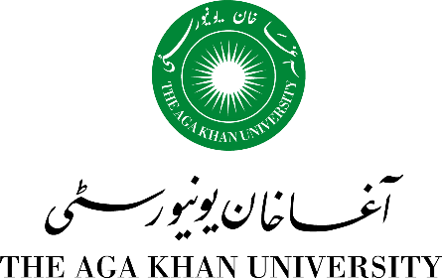

26th National Health Sciences Research Symposium

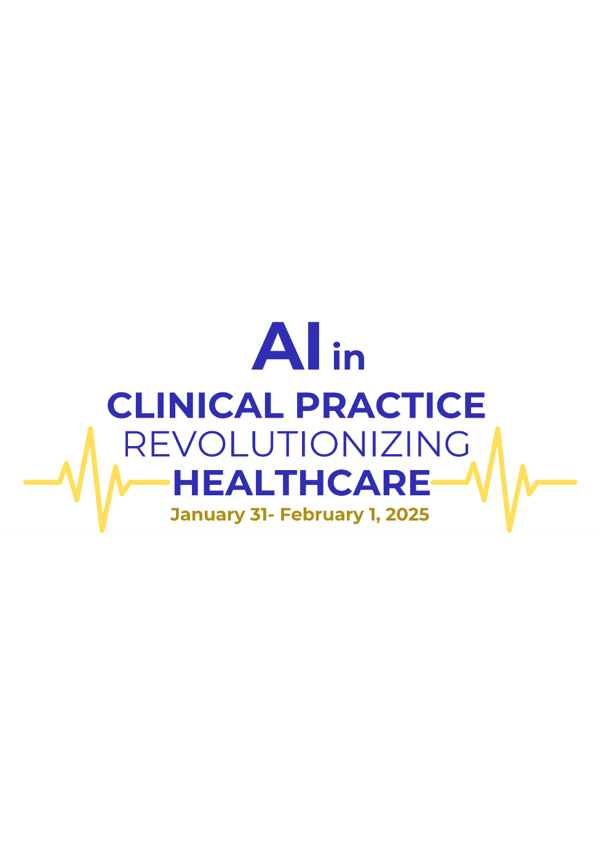

PROGRAMME

INAUGURAL CEREMONY
Friday, January 31, 2025
AKU Auditorium

I

(Master of Ceremony: Ms. Yasmeen Parpio)
5:30 - 5:35 pm | Recitation of the Holy Qur’an
5:35 - 5:40 pm | National Anthem
5:40 - 5:55 pm | Overview of the symposium  Dr Natasha Ali  Chair, Organizing Committee  26th National Health Sciences Research Symposium
5:55 - 6:05 pm | President’s Remarks
6:05 - 6:15 pm | Welcome Remarks  Dr Adil Haider  Dean, Medical College, Aga Khan University  Dr. Laila Ladak  Interim Associate Dean for Research and Innovation
6:15 - 6:30 pm | Remarks by the Chief Guest
6:30 – 7:00 pm | Keynote Talk 1  Dr Tracie Risling  Associate Dean Innovation, Faculty of Nursing, University of Calgary
7:00 – 7:30 pm | Keynote Talk 2  Dr Zara Cooper  Director, Centre for Surgery and Public Health  Director, Centre for Geriatric Surgery  Michele and Howard J. Kessler Distinguished Chair in Surgery and Public Health  Professor of Surgery, Harvard Medical School Trauma, Burn and Surgical Critical Care
7:30 - 8:00 pm | Keynote Talk 3:  Dr Mayur Narayan  Professor of Surgery  Chief, Division of Acute Care Surgery Trauma Medical Director, Project AiCCESS [Artificial Intelligence for Comprehensive, Care, Equity and Sustainability in Surgery], Rutgers Robert Wood Johnson Medical School
8:00 - 8:10 pm | Vote of Thanks  Dr Sadia Fatima  26th National Health Sciences Research Symposium  The Aga Khan University
8:10 pm | Dinner at Male Hostel Lawn

DAY-2
Saturday, February 1, 2025
AKU Auditorium

(Master of Ceremony: Dr Rozmeen Akbar)

8:30 - 9:00 am | Registration
9:00 - 9:05 am | Opening of the Conference
9:05 - 9:25 am | Plenary Talk – I – Dr Patricia Geli  Co-founder, managing director, and COO at C10 Labs
9:25 – 9:45 am | Plenary Talk – II – Dr Yasar Ayaz  Professor, NUST School of Mechanical and Manufacturing Engineering  Head, Department of Robotics & Machine Engineering
9.45 - 10:30 am | Tea Break at pond side
10:30 - 11:30 am | THE GREAT DEBATE  The AI Dilemma: Ethics vs. Innovation in Healthcare  Moderators: Dr Sadia Fatima and Dr Wafa Jamil
11:30 am -11:50 pm | Plenary Talk – III – Shahid Azim  Co-founder and CEO, C-10 Labs  CEO, Managing Partner, Co-founder Deep Tech Entrepreneur
11:50 am -12:10 pm | Plenary Talk – IV – Dr Adil Haider  Professor & Dean Medical College
12:10 am -12:30 pm | Plenary – V – Arhum Ishtiaq  Cofounder at Connecthear  TRT World Citizen Award 2025  Pride of Pakistan 2024  WSA Young Innovator 2020
12:30- 2:00 pm | Poster viewing, prayer break and lunch at male hostel lawn
2:05 - 3:30 pm | ORAL PRESENTATIONS’ SESSION  Chair: Dr Fatima Mubarak  Co-Chair: Dr Bilal Qureshi  Judges: Dr Fareena Bilwani, Dr Najia Ganchi  - Developing an AI-Based Application for Caries Index Detection on Intraoral Photographs  Ayesha Noor Uddin  - Application Of Artificial Intelligence (AI) Models to Detect Gastro-Luminal Pathologies Associated with H. Pylori Using Upper GI Endoscopy  Om Parkash  - Revolutionizing Local Anesthesia Training in Dentistry: A Comparative Study of AI-Driven Virtual Simulation Versus Medium Fidelity Simulation  Rabia Anis  - AI-Assisted Precision Grading of Blastocysts for In Vitro Fertilization  Shahzaib Khan  - Navigating Responsible AI: Pathways to Equitable and Just Health Systems in the Global South  Simran Siraj  - Predicting the skeletal classification in orthodontic patients using sagittal parameters based on Artificial Intelligence  Zahra Masood  - Establishing a Center for Artificial Intelligence in Health Sciences at ICCBS  Reaz UDDIN
3:30- 4:45 pm | AI Snapshots  Presenters:  1.Dr Haroon Tayyab  2. Ms. Ayesha Mansoor, Ms. Azra Naseem, Dr Sadia Fatima, Dr Shahid Shamim (group)  3.Dr Zahra Hoodbhoy  4.Dr Fahad Umar
4:45 – 5.15 pm | Awards & Closing Remarks  by Ms. Khairunnisa Mansoor  Co-Chair, Organizing Committee  26th National Health Sciences Research Symposium  Senior Instructor • School of Nursing & Midwifery
5.15 pm | Hi-Tea

- End of the Programme –

